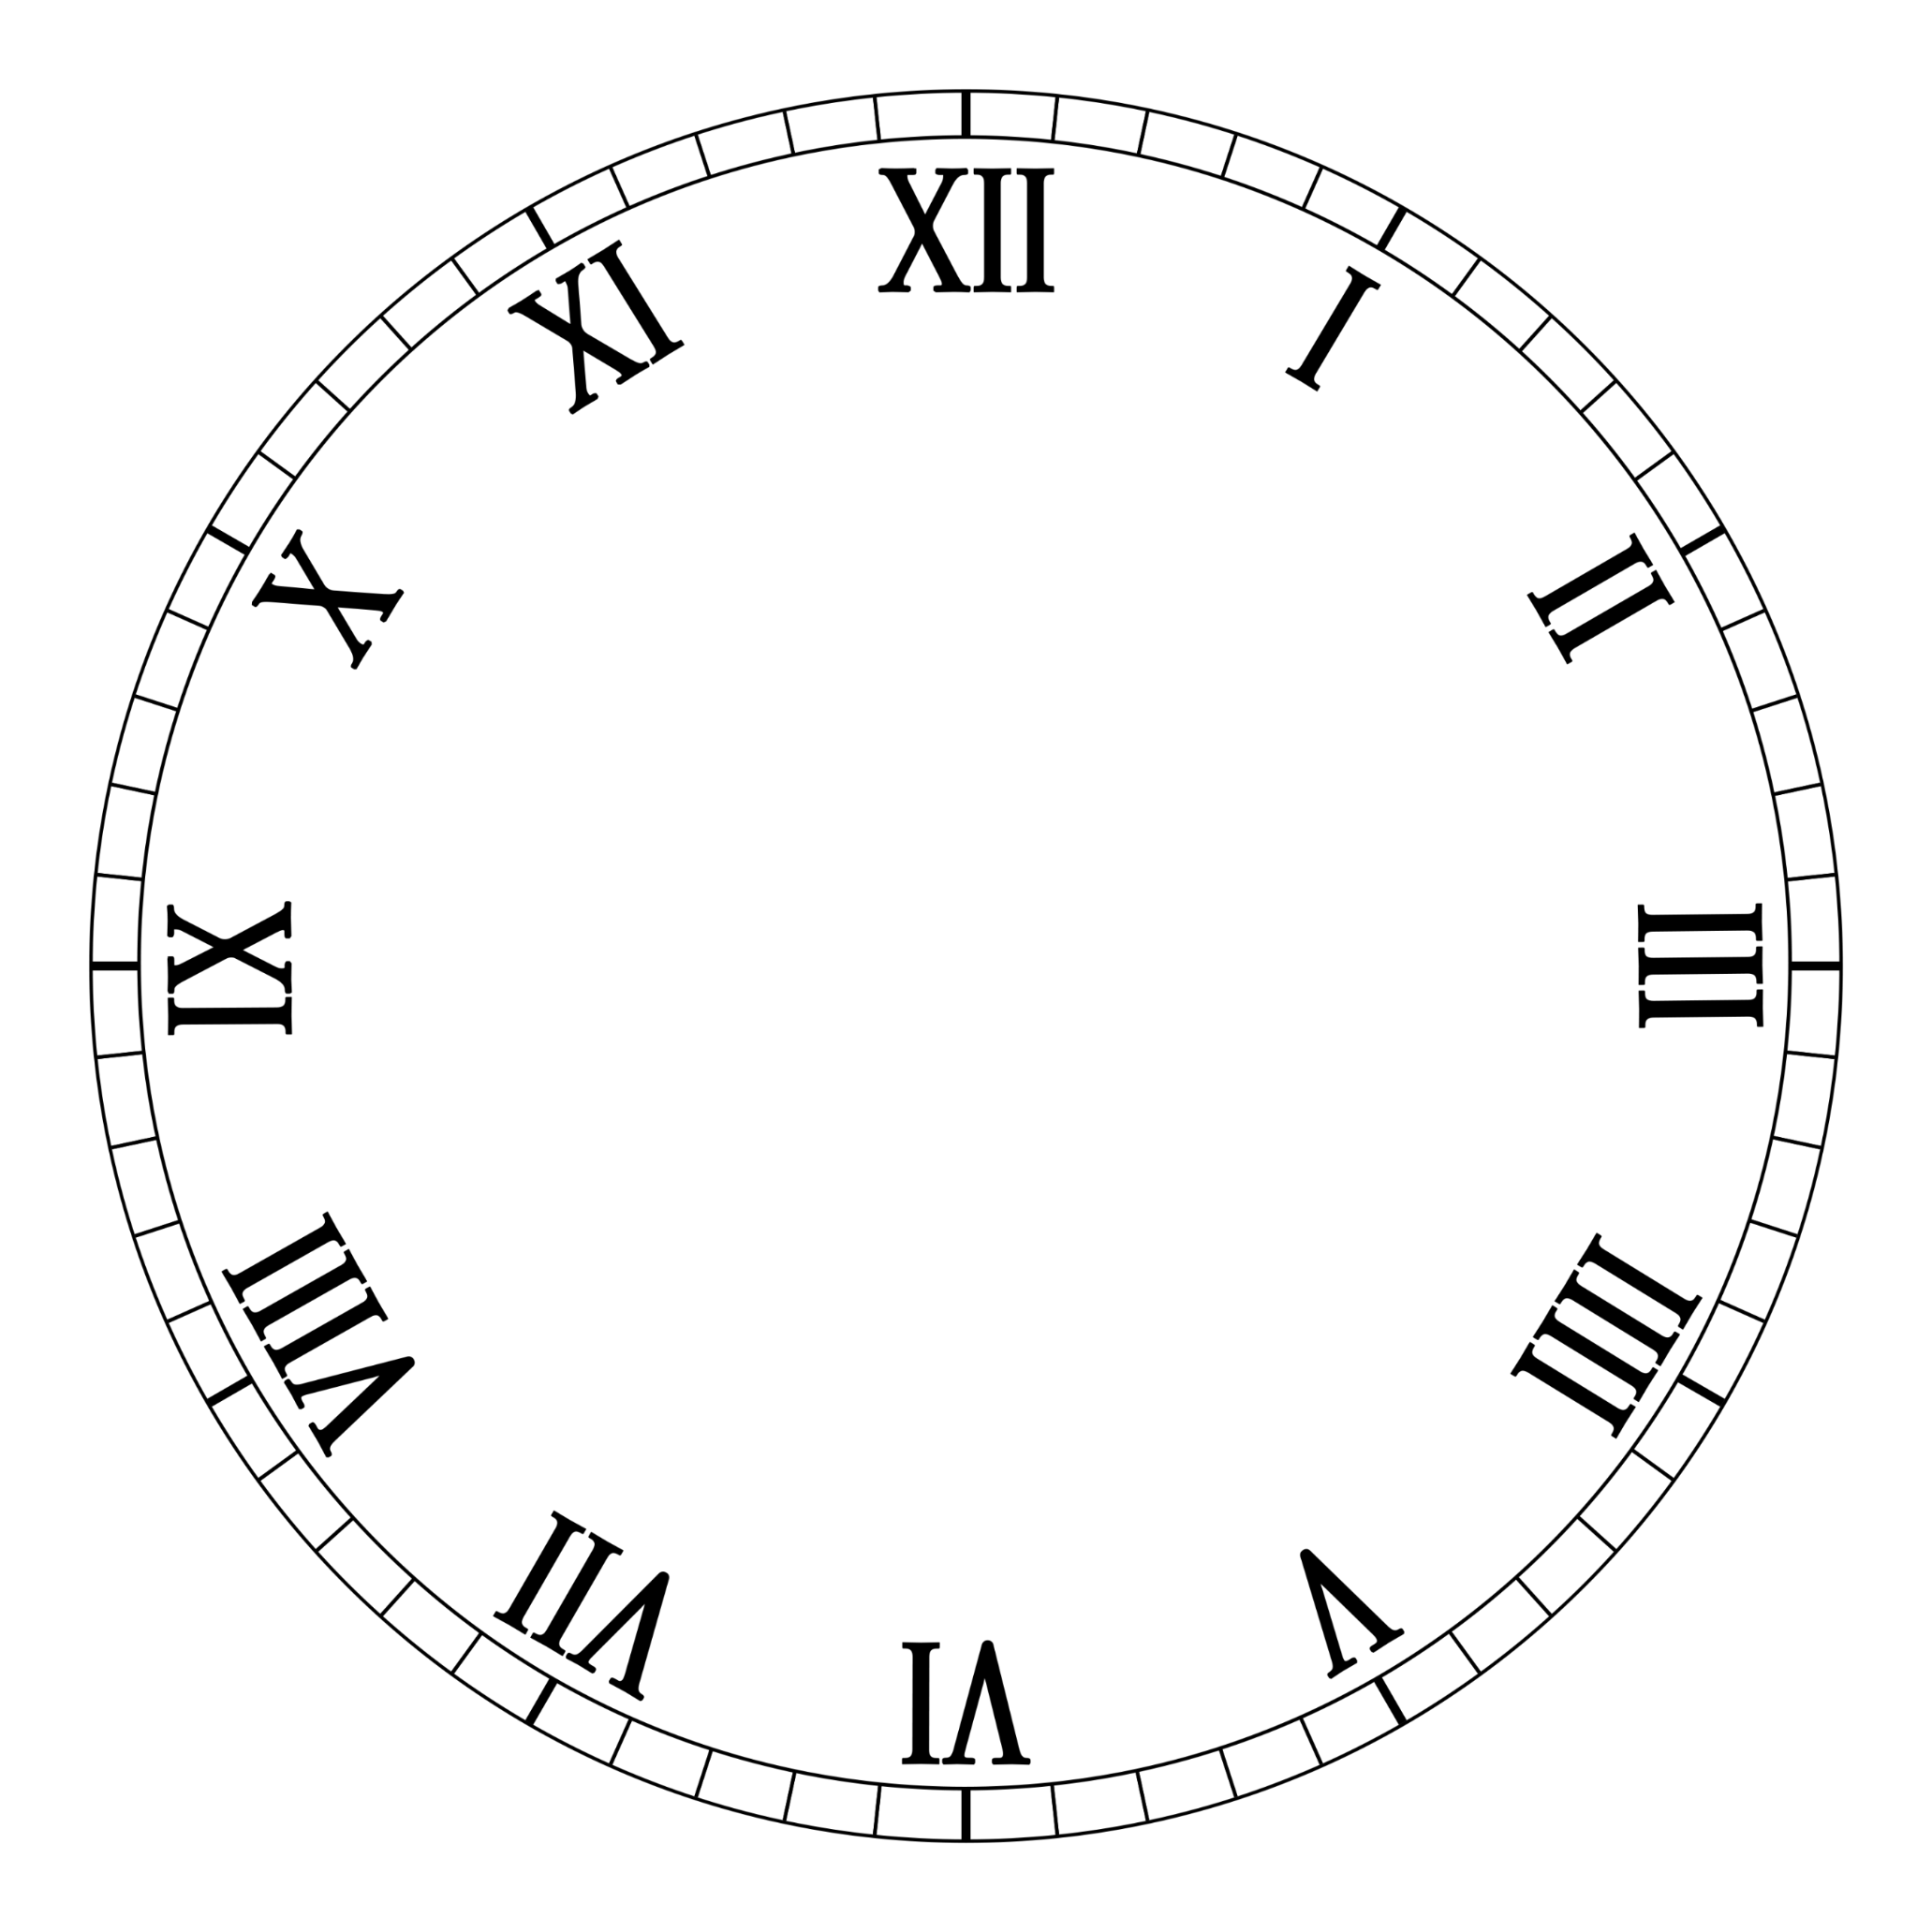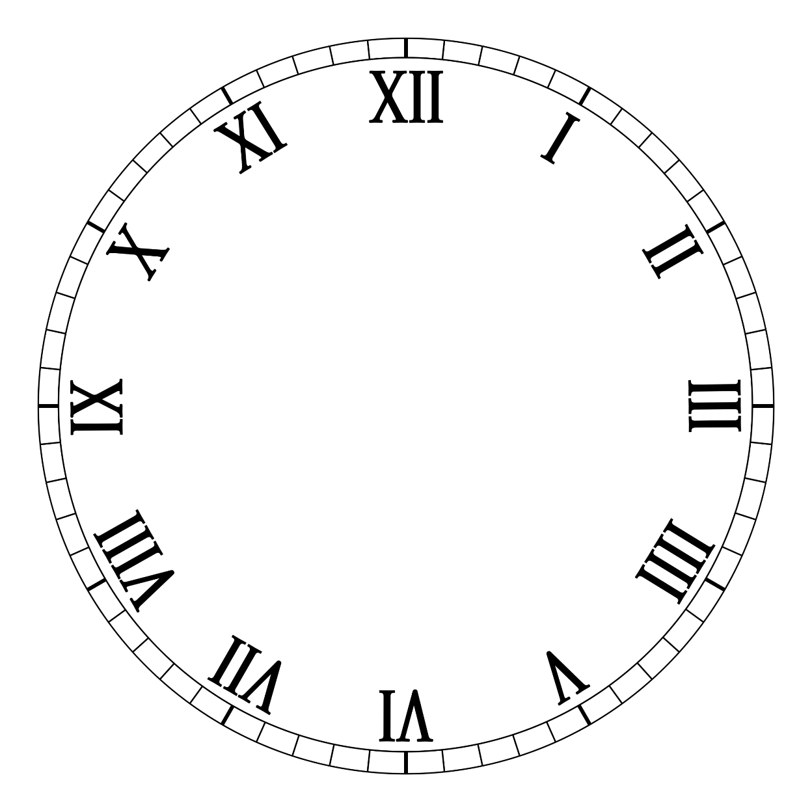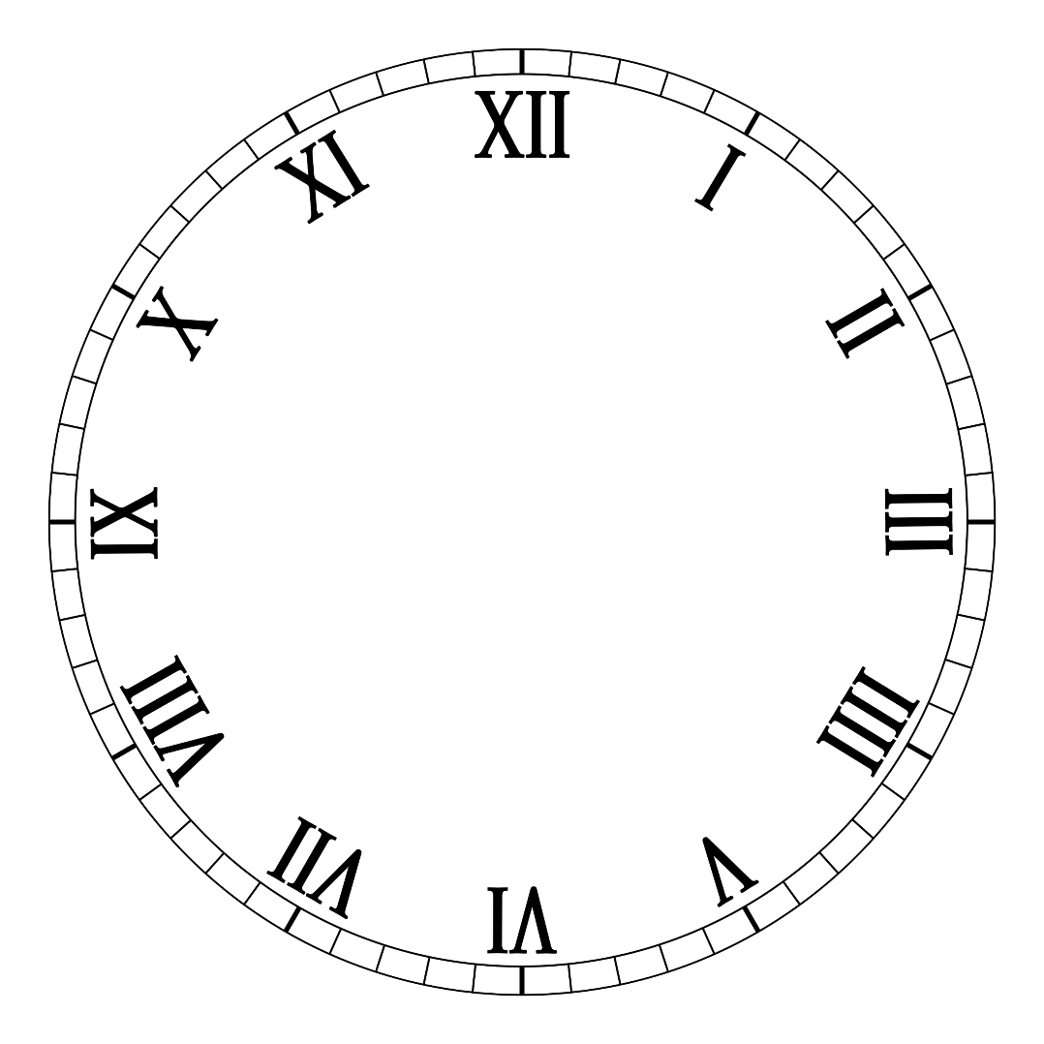

**HISTORIC HOUR**

**2022**

Contents

1. Introduction 1

2. Entry and Exit criteria 1

2.1 Entry Criteria 1

2.2 Exit Criteria 1

3. Goals and Tasks 2

3.1 Goals 2

3.2 Tasks 2

4. Coverage 2

4.1 Manual Testing 2

4.2 Unit Testing 2

5. Approach 2

5.1 Techniques that we used for testing 2

6. Testing process 3

6.1 Testing results 3

6.2 Resources 3

# Introduction

This is a document that contains plan for testing the program for our school project. Our program is an app made with C++, for the sprint “Linked Lists”. The aim of the app is to create, search and sort out events.

# Entry and Exit criteria

## 2.1 Entry Criteria

* There is an access to the program
* The first tests are sorted
* Unit testing is ready

## 2.2 Exit Criteria

* All the tests are passed
* There are no critical errors that deny the program to work

# Goals and Tasks

## 3.1 Goals

Our goals were to create a program that can help people create, search or sort out with filters events.

## 3.2 Tasks

The tasks that are required for the good condition for our game are:

* To test the most important elements
* To create more test cases
* Doing manual and unit testing
* To make a report for all the tests

# Coverage

## 4.1 Manual Testing

* Interface of the game
* Menu options
* Testing if you can type in
* See if we can filter by Title, Year or Topic

## Unit Testing

* Testing if the program can return binary representation of numbers
* Testing if the program can return gray code representation of numbers
* Testing if the program takes node index
* Testing if the program takes last node position
* Testing if the program checks valid spaces

# Approach

## 5.1 Techniques that we used for testing

* Testing usability
* Functional testing

# Testing process

## 6.1 Testing results

* Test case lab and excel reports with Test Suites and different test cases
* Test Plan

## 6.2 Resources

* GitHub for planning the QA Tests
* Test case lab and excel for reporting and managing the tests